**Phase reconstruction: Lab Activity**

Activity objective: build a telescope to magnify a He-Ne laser and acquiring images of the laser profile at different distances. These images will be used in the afternoon for the phase reconstruction.

Materials: Positive (f = 380 mm) and negative (f = -75 mm) lenses. Irises, Camera, two wedges, rail, marker and laptop.

Walkthrough and tasks:

To get enough resolution, we need to expand the He-Ne beam profile.

* Expand the He-Ne Laser using the two lenses to build a Galileian beam expander.

We need to attenuate the beam without affecting its quality. We can do this by using two wedges.

* Mount the wedges following the scheme depicted in the figure to have the beam propagating along the rail where the camera will be placed

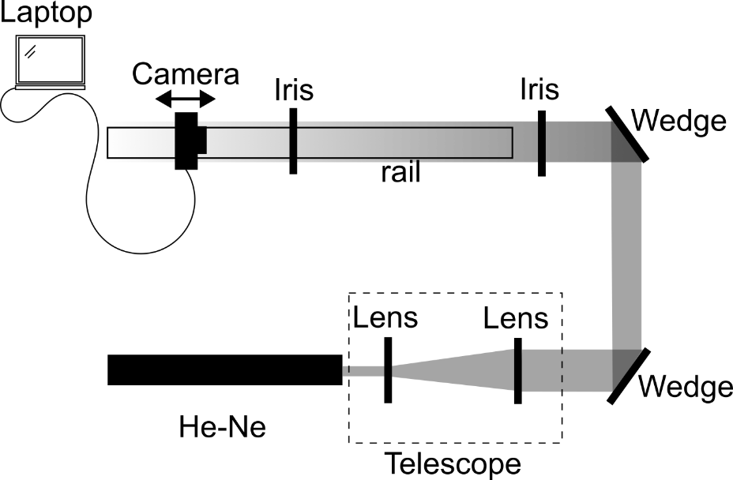

* With the help of two irises, make sure the beam is parallel to the rail (then remove the irises)
* Mount the camera and place it on the rail (block the beam during this operation)
* Connect the camera to the computer, turn both on and open the software pk tether
* Chose you iso and acquisition time and take one picture of the beam
  + Adjust the acquisition settings if needed
* Try to moove the camera along the rail and take pictures in different position
  + Is the image of the beam moving around or it is always in the same position?
  + If it is changing position we need to fix it. What should you do?

Once satisfied with the alighment and acquisition parameters it’s time to get the image for the data analysis session.

* Moove the camera to one extreme of the rail and take one picture, then reach the other side of the rail in steps, taking one picture for each step. The total distance covered should be at least 60 cm with a minimum of 4 steps. Feel free to have more steps if you like. Make sure to label each image properly and note down all the information regarding the distances bewtweeen each frame.
* Repeat the procedure just for two steps (20 cm apart) but with one of the lens which is not normalized