## Unraveling the Synergistic Impact of Anthropogenic and Biogenic Emissions on New Particle Formation: Evidence from the CERN CLOUD Chamber

## A.Pignatelli1, B. Yang2, L.Liu2 , L. Dada2 , I. El Haddad2

### 1Dipartimendo di Fisica, Università degli Studi di Napoli Federico II, Piazzale Vincenzo Tecchio 80, 80125, Napoli, Italia

### 2 Laboratory of Atmospheric Chemistry, Paul Scherrer Institute, PSI, Villigen, 5232, Switzerland

### Email of communicating alessia.pignatelli@unina.it

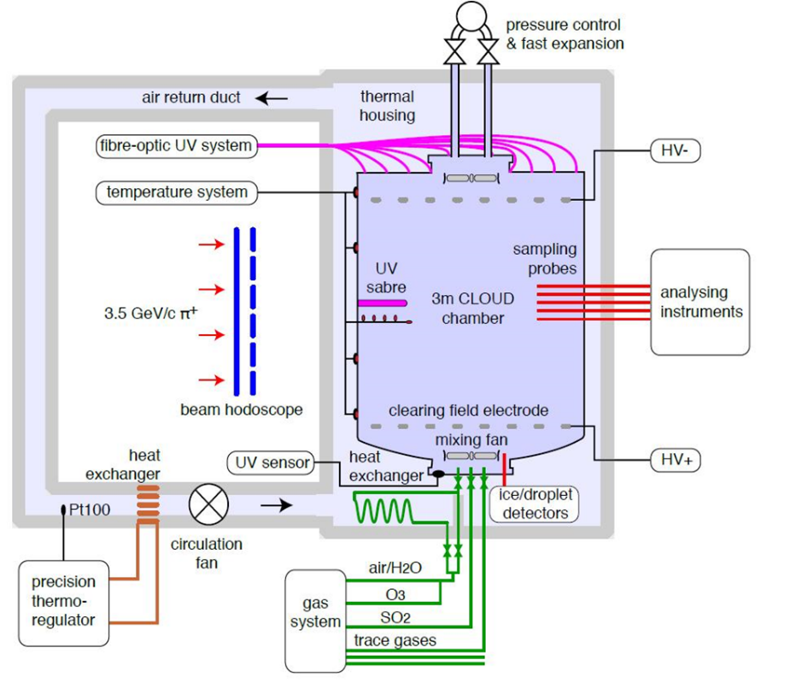New particle formation (NPF) plays a critical role in the atmospheric aerosol population, influencing both climate and human health (Lai, 2024). Understanding the driving mechanisms behind this process is essential for accurately assessing the anthropogenic impact on our planet.

Several studies have recently pointed out the crucial role covered by RO2-RO2 interactions and their contribution to dimers formation and consequently to NPF (Kenagy, 2024). Here, the understanding of the synergistic effects of biogenic and anthropogenic volatile organic compounds (BVOC and AVOC, respectively) on dimers formation and NPF is proposed. The study explores three distinct scenarios: emissions dominated by biogenic VOCs (representing a forest environment), a mix of anthropogenic and biogenic VOCs (typical of suburban areas), and emissions dominated by anthropogenic VOCs (characteristic of highly polluted urban settings).

Data presented have been collected at CERN CLOUD (Cosmic Leaving Outdoor Droplets) chamber, located in Geneva. Continuous sampling using mass spectrometers, particle size distribution analyzers, and filter deposition techniques enables real-time monitoring of the evolution of various compounds, allowing for the isolation of their contributions from the gaseous phase to the particle phase.

The goal is to provide a clear understanding of the gas-to-particle mechanisms driving NPF, with a focus on assessing the contribution of human emissions on climate and on clarifying the role of RO2 on atmospheric mechanisms.

Lai S., Ximeng Q. et al (2024), *Atmos. Chem. Phys.*, 24, 2535–2553.

Kenagy H. et al (2024), Sci. Adv, 10, eado1482.

**Keywords: Dimer formation, Anthropogenic-Biogenic Interaction, Air quality**