Paper Title (please do not change margins/fonts )
Paola Rossi¹, Eune Sempio¹*, Se Guiquesto^{1,2}
¹National Research Council (CNR), Institute for Biological Resources and Marine Biotechnologies (IRBIM), Largo Fiera della Pesca, 2,
60125 Ancona, Italy
² Biodiversity, Biotechnology and Climate Change Laboratory (LR11ES09), University of Tunis El Manar, Tunis, Tunisia
*E-mail: eune.sempio@cnr.it

Short summary: This abstract should in maximum two or three lines summarize the findings of the paper in relation to the main theme of the congress, which is contemporary biodiversity changes. Please do not alter margins and text fonts of this template
Keywords: Max 6 keywords, Max 6 keywords, Max 6 keywords, Max 6 keywords, Max 6 keywords, Max 6 keywords,
NOTE: Contributions presenting perspectives and opinions are welcome and may benefit from a certain flexibility in the structure of this template, within the confines of the one-page limit.

I. Background
Overall, the background section serves as a foundation for the research paper, providing readers with the necessary information to comprehend the significance of the study and why it is being conducted [1]. Here you can contextualize your research within a broader scope. Clear objectives can be outlined.
Materials and Methods
You have limited spaces and there is no need to be really detailed, but put the essential information to explain how and with what procedures/methodologies/ materials you conducted the research.
a + b = c
This template is intended to be used to format your paper and style the text. All margins, column widths, line spaces, and text fonts are prescribed; please do not alter them.

Results

A. You might use headings but this is optional
Clearly you know that the results section of this paper should present the findings of your study based on the data collected during the research. This is clear but we need to write something in this template. You might add a maximum of one Table and one Figure: See what is written in Tab I.
- Instructions with a stupid example
Note | Your table must have this stile*
 | Table column subhead | Subhead | Subhead
here | Only if you have a table | 222 | 12
*Sample of a Table footnote. (Table footnote)

B. This title is just an example

In this example we decided to divide the results in two sections (A and B) but also to put a figure with a crab (Fig 1). “This is a story of our changing planet, and what we can do to help it thrive… The truth is: the natural world is changing. And we are totally dependent on that world. It provides our food, water and air. It is the most precious thing we have and we need to defend it.”. Who is this?

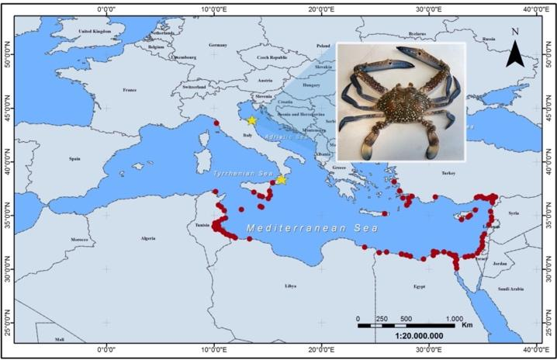

Fig. 1. This figure has been reproduced from a published paper [1] and it is just one example of a figure. You may choose whether to include a figure or not, based on the relevance and clarity it adds to the presentation of your findings.

Discussion and main conclusions
Here authors can explore the implications of the findings in the context of research objectives, taking in mind the need to highlight contemporary biodiversity changes. Including a conclusion would add closure to the work, emphasizing the significance of the findings and delivering your message (for example proposing potential directions for future research). By contextualizing seemingly isolated cases within a broader framework, our objective is to underscore their relevance. You are now equipped to format your paper; utilize this straightforward template to submit your contribution, and we look forward to welcoming you soon in Fano!"

Acknowledgment
We are grateful to the IEEE Computational Intelligence Society and to the Mediterranean Science Commission CIESM, which inspired the design of the current word template.
References (max 3)

- Barbier, Edward B., Joanne C. Burgess Barbier, and Carl Folke, eds. Paradise lost?: the ecological economics of biodiversity. Vol. 2. Routledge, 2019.
- Grati, F., Froglia, C., Souissi, J.B., Bolognini, L. and Azzurro, E., 2023. The blue swimming crab Portunus segnis (Forskål, 1775) reaches the Adriatic Sea: A distant and disjointed occurrence. BioInvasions Rec, 12 (10.3391).
- Rockström, J., Steffen, W., Noone, K., Persson, Å., Chapin, F.S., Lambin, E.F., Lenton, T.M., Scheffer, M., Folke, C., Schellnhuber, H.J. and Nykvist, B., 2009. A safe operating space for humanity. nature, 461(7263), pp.472-475

